Welcome to the
2018 SEFA Campaign!
AGENCY NAME has been participating in the SEFA campaign for XX years. Please considering joining us by participating in this year’s campaign.

Every contribution, big or small, can make an impact on people in need. Agencies supported by the SEFA Campaign help people of all ages and backgrounds in need of health and human services as well as cultural, historical and environmental resources right here in our own community.

Contact XXX at XXX if you need assistance filling out your pledge form or have a question about the SEFA Campaign.

Thank you for your time and generosity.

Sincerely,
NAME
2018 SEFA Employee Campaign Coordinator
PHONE/EMAIL

SEFA Events Calendar
- DATE – Campaign Kick Off
- DATE – Campaign Fundraising Event
- DATE – Campaign Ends

Campaign Highlights
- Campaign Goal - $$$$$$
- Amount Raised in 2017 - $$$$$

Online Pledging Option
State employees can complete the pledge process through a simple online system allowing you to search for your favorite charities and make a secure, paperless pledge at giveattheoffice.org/_nyssefa/

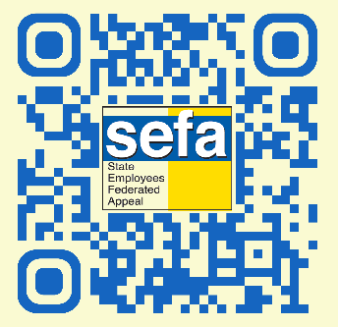

SEFA Planning Team
- List planning team members

For more information visit sefa.nys.org (or your office website link) or facebook.com/nys.sefa/

Enter campaign dates here

Enter contact name and
phone number here

